  computer network  Sir Shakeel | M. Abdullah Khalid  2023-BS-AI-035 (A)

Table of Contents

Lab – 1 Introduction to Cisco Packet Tracer 3
Lab – 2 IP Assigning, Commands for CMD, Labeling method, Simple packet Transformation 7
Lab – 3 Constructing a basic network using two personal computers 11
Lab – 4 Study of Ethernet Cables, Categories, RJ45 Connector & Wiring Standards 15
Lab – 5 Make local area network using switch 18
Lab – 6 Repeaters & Routers with Switches & Hubs 21
- Lab – 7 Router Configuration 27
Lab – 8 Routers with Switches, PCs & Laptop / Bridges with 2 Switches, PCs & Laptop 30
Lab – 9 Network Devices 33
Lab – 10 Static Routing 36
Lab – 11 RIP (Routing Information Protocol) 40
Lab – 12 Introduction to Subnetting 44
Lab – 13 IoT Simulation 47
Lab – 14 Configuring VoIP phones using Cisco packet tracer (IP Telephony) 50
Lab – 15 ACL configuration in cisco packet tracer 54

Lab – 1 Introduction to Cisco Packet Tracer
Goals of this Lab
After completing this lab, students will be able to:
- Understand what Cisco Packet Tracer is and why it is used.
- Learn how networking is taught using virtual simulation instead of physical devices.
- Identify basic networking devices such as routers, switches, PCs, and others.
- Use the software interface and understand its main components.

What is Packet Tracer?
Cisco Packet Tracer is a network simulation tool developed by Cisco Systems.
It allows students to:
- Create virtual network topologies on a computer
- Connect networking devices like routers, switches, and PCs
- Configure and test networks without real hardware
- Practice troubleshooting network problems in a virtual environment
It is mainly used for learning networking concepts and CCNA practice.

Devices Available in Packet Tracer
The simulation includes many networking devices such as:
- Routers (connect different networks)
- Switches (connect devices within a LAN)
- Hubs (basic networking device)
- PCs and Laptops (end devices)
- Servers (provide network services like web and email)
- Wireless devices (for Wi-Fi connections)
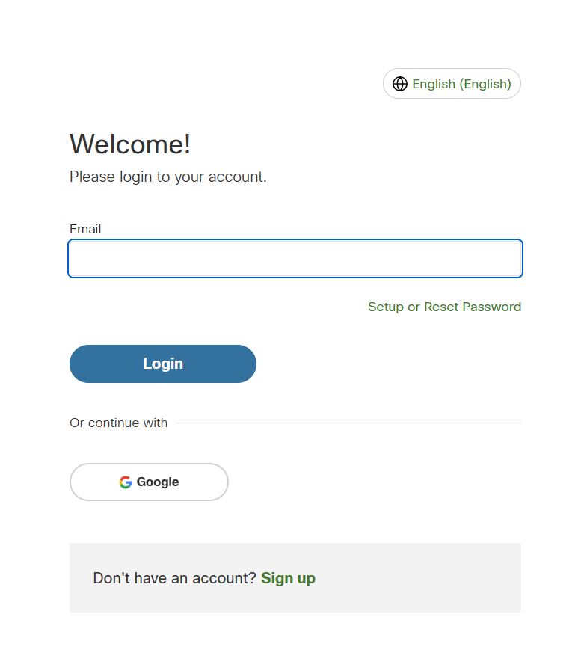

Core Functionality
The main purpose of Packet Tracer is to connect theory with practical networking skills.
It provides a safe virtual environment where users can:
- Practice device configuration without real hardware
- Build and design different types of networks
- See how data packets move between devices in a network
- Learn by doing instead of only reading theory
This hands-on approach helps students understand networking concepts better and improves their problem-solving skills needed for real-world network management.
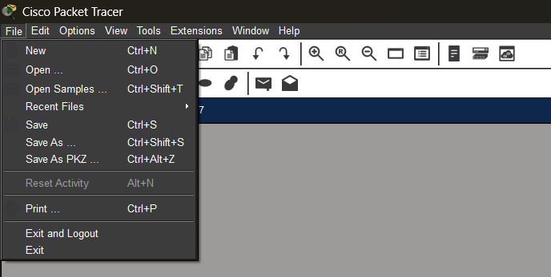
Key Benefits of the Platform
- Beginner-friendly interface
- Eliminates dependency on physical hardware investments
- Allows full network simulation
- Comprehensive coverage of CCNA examination objectives
- Integrated diagnostic and troubleshooting toolkit
Setup & Authentication
- Download the installer from the official Cisco Networking Academy site
- Run the setup and complete the installation
- Launch the application
- Sign in with a Cisco account or continue using Guest Login
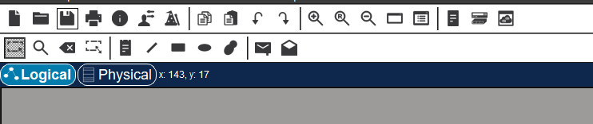
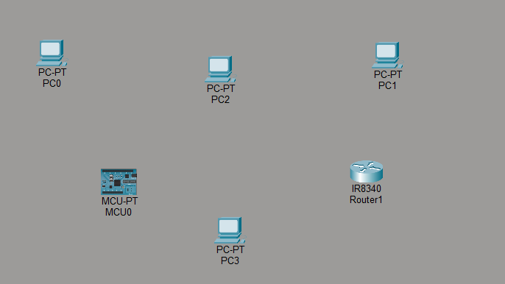

Interface Navigation Guide
Menu Bar
Provides options for creating, opening, and saving project files
Toolbar
Holds tools for selecting, moving, deleting, and zooming objects
Workspace
The central area where the network topology is created and designed
Device-Type Selection Box
Displays categories of devices such as routers, switches, end devices, and connections
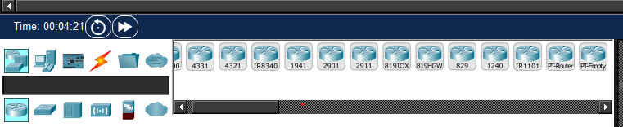
5. Simulation Panel: Lets the user watch packets move step by step through the network.
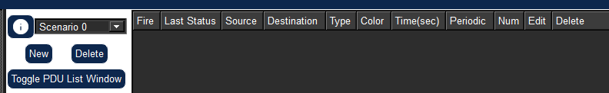
Lab – 2 IP Assigning, Commands for CMD, Labeling method, Simple Packet Transformation
Network Address Allocation
In any network environment, every device must have a unique IP address to identify it and allow proper communication. This address works like a location address, helping data reach the correct device within the network.
Implementation Steps
Phase 1
Start Cisco Packet Tracer
Phase 2
Open the End Devices category from the device selection panel
Phase 3
Place two computers in the workspace and name them PC-0 and PC-1
Phase 4
From the Connections section, select the Copper Cross-Over cable
Phase 5
Connect PC-0 to PC-1 using the cable


Workstation Address Configuration
- Click the PC-0 icon.
- Open the Desktop tab.
- Choose IP Configuration.
- Enter the address details as specified.
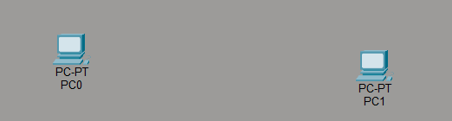
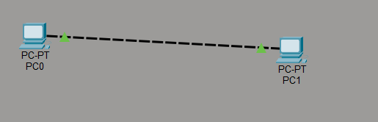
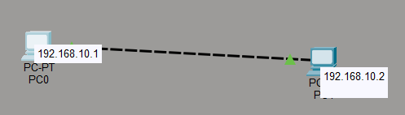

Terminal Diagnostics
The Command Line Interface, accessible through the Command Prompt utility within Packet Tracer, provides powerful diagnostic capabilities for verifying network connectivity, examining interface configurations, and analyzing protocol behavior at the operating system level.

Implementation Steps
- Click PC-0.
- Move to the Desktop tab.
- Open Command Prompt.
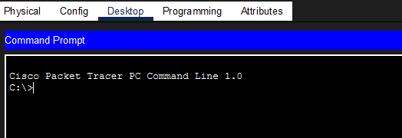

Connectivity Verification
To validate the communication pathway between the two endpoints, execute the following command:
ping 198.168.10.2
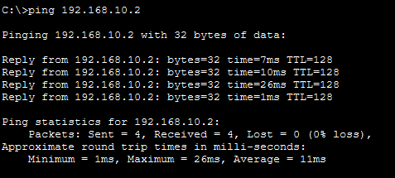

Network Interface Details
To display the full network configuration of the PC, enter:
ipconfig /all
Upon execution, this command displays comprehensive network interface information including the logical IP address, subnet mask defining the network segment, physical MAC (Media Access Control) address, and the default gateway responsible for routing traffic beyond the local network.
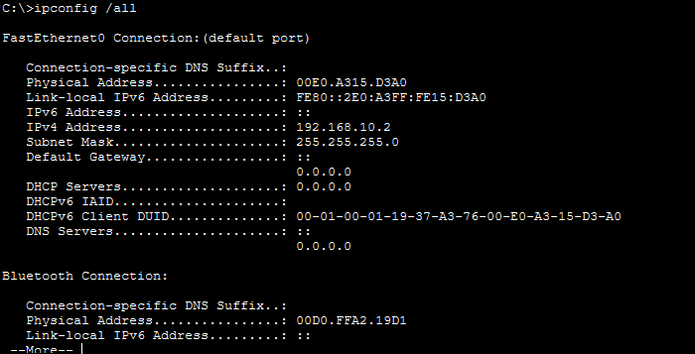

Topology Annotation
Labels (notes) are placed on the workspace to identify devices and to document the topology clearly.

Implementation Steps
- Pick the Place Note tool from the toolbar.
- Click any empty point on the workspace.
- Type labels such as PC-0, PC-1, and Network Connection.
- Drag the notes into position if needed.
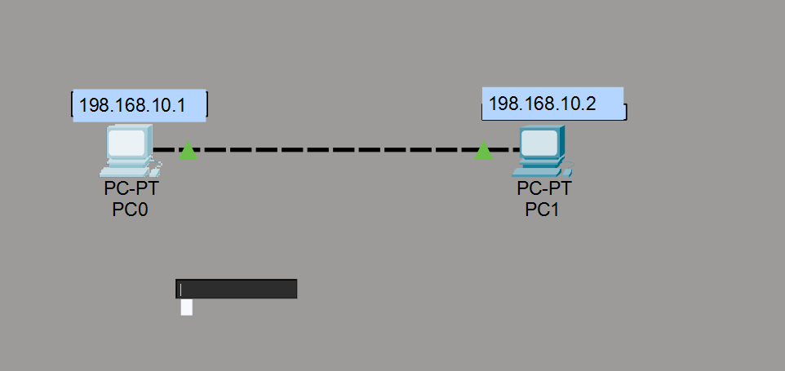

Data Transfer Testing
In this exercise, a Protocol Data Unit is generated and transmitted between two network hosts operating in simulation mode. This process serves as a practical validation mechanism to confirm that the established network connection supports successful end-to-end communication.

Implementation Steps
- Change from Real-Time Mode to Simulation Mode.
- Choose the Add Simple PDU (envelope) tool from the toolbar.
- Click PC-0 to mark it as the source.
- Click PC-1 to mark it as the destination.
- Observe the animated packet traversal across the network link connecting both machines. The appearance of a green verification indicator within the event log provides definitive confirmation that the data transmission completed without errors.

Lab – 3 Constructing a basic network using two personal computers

A computer network consists of two or more computing devices connected together to share resources and exchange information. In this laboratory exercise, two computers are directly connected using a Copper Cross-Over cable. Since there is no intermediate device such as a switch or router involved, this setup is known as a Peer-to-Peer network topo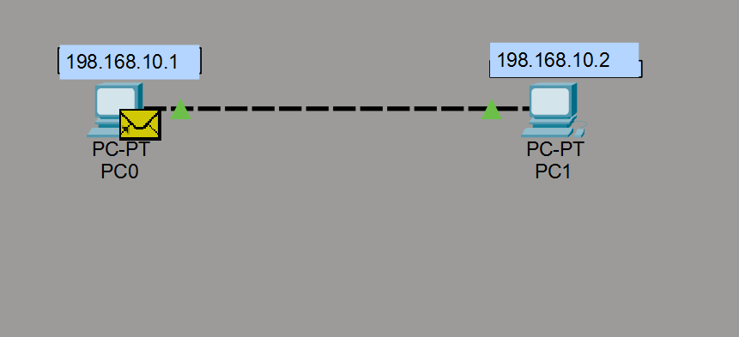logy.
Materials & Tools
- Two PCs / laptops
- One Copper Cross-Over cable
- Cisco Packet Tracer software
Implementation Steps
Phase 1
Start Packet Tracer: Open the Cisco Packet Tracer application
Phase 2
Add the Computers:
- Choose End Devices from the device-type section
- Drag two laptops into the workspace and name them PC-0 and PC-1
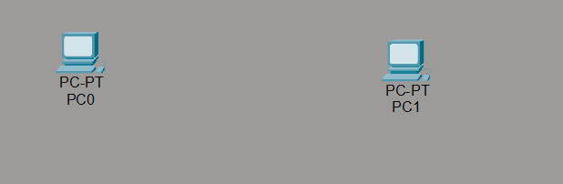
Phase 3: Connect the Two Machines:
- Open the Connections category.
- Pick the Copper Cross-Over cable.
- Join FastEthernet0 of Laptop-0 to FastEthernet0 of Laptop-1. Green link lights at both ends indicate the physical connection is up.
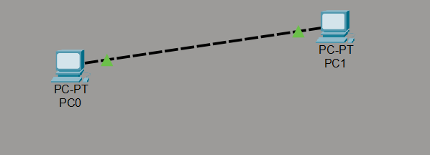
Phase 4: Configure the First Machine:
- Click Laptop-0.
- Open the Desktop tab.
- Select IP Configuration.
- Enter the values from the configuration table.
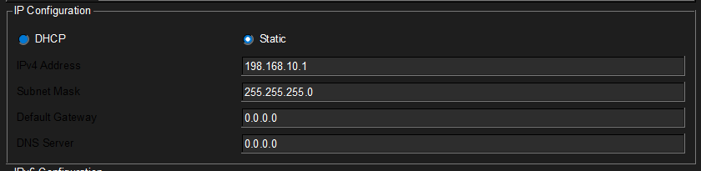
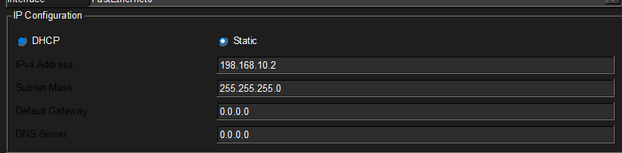
Phase 5: Check Connectivity:
- Click Laptop-0.
- Open Desktop → Command Prompt.
- Type the command: ping 198.168.10.1
The reception of reply messages from the target host serves as conclusive evidence that the two computers have established successful network communication and can exchange data packets bidirectionally.
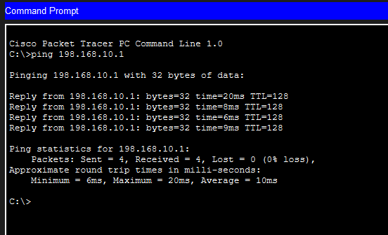
Phase 6: Test in Simulation Mode:
- Move to Simulation Mode.
- Pick the Add Simple PDU tool.
- Click Laptop-0 first and then Laptop-1.
- Monitor the animated packet movement traversing the physical cable medium. The successful delivery is visually confirmed by a green check mark indicator appearing in the event tracking panel.
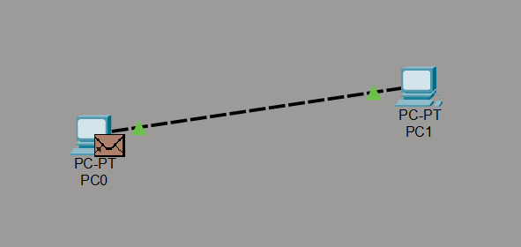
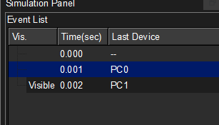

Lab – 4 Study of Ethernet Cables, Categories, RJ45 Connector & Wiring Standards

Goals & Competencies
By the end of this lab session, students should be able to:
- Articulate the fundamental role of Ethernet cabling in wired network infrastructures.
- Enumerate the standardized cable categories and their corresponding transmission performance specifications.
- Detail the physical structure and pin configuration of the Registered Jack 45 connector.
- Differentiate between the T568A and T568B standard wiring conventions and their respective applications.
- Distinguish between straight-through and cross-over cable types based on their wiring patterns and use cases.

Practical Exercise

Background & Context
Ethernet cabling constitutes the physical transmission medium responsible for carrying electrical signals between interconnected network devices including workstations, switches, routers, and hubs. Within Local Area Network deployments, the most prevalent cable variant is the Unshielded Twisted Pair (UTP), which utilizes twisted conductor pairs to minimize electromagnetic interference and crosstalk while maintaining cost-effectiveness.
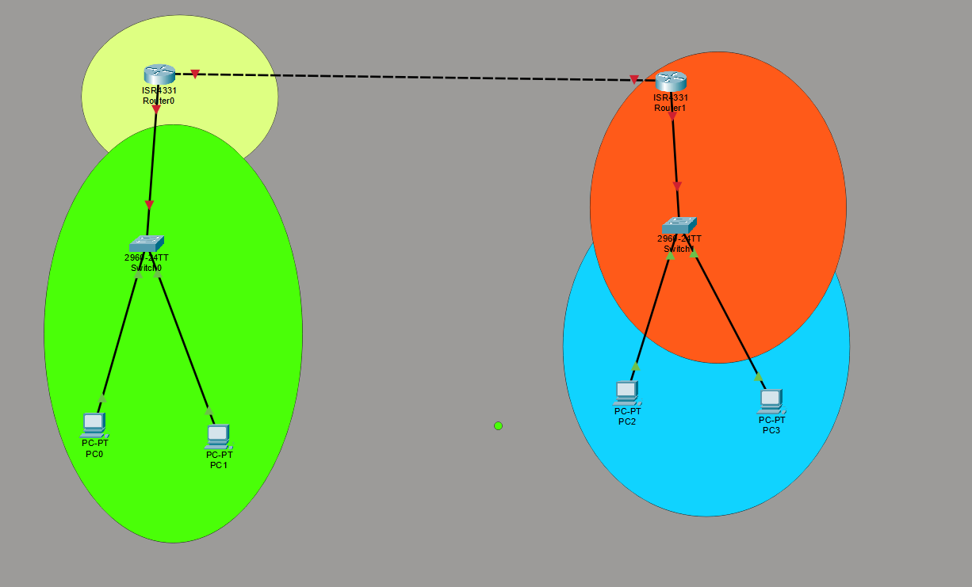

Cable Variants
1. Straight-Through Cable
A straight-through cable facilitates connectivity between dissimilar device types, utilizing identical wiring standards at both connector ends. Common deployment scenarios include connecting workstations to switches, switches to routers, and computers to hub devices.
2. Cross-Over Cable
A cross-over cable enables direct communication between identical device categories by crossing the transmit and receive signal pairs internally. Typical applications include PC-to-PC direct links, switch-to-switch connections, and hub-to-hub daisy chaining.
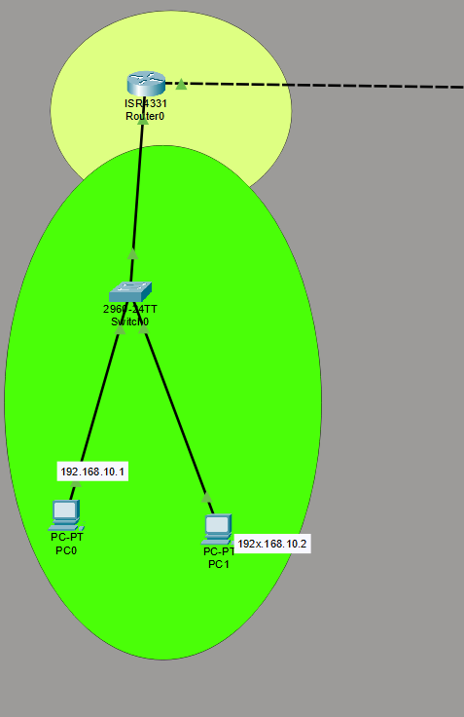

Performance Classifications
The Ethernet standard defines multiple cable categories, each engineered to support specific maximum data transfer rates and bandwidth requirements:
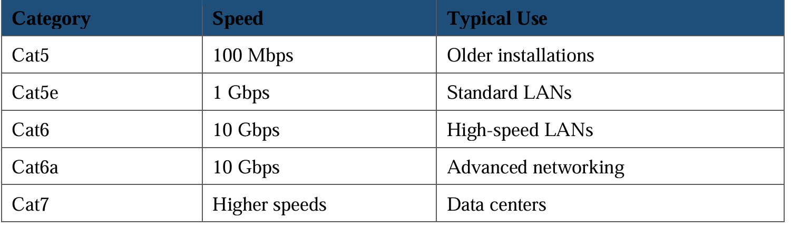

Hands-On Walkthrough
- Open Cisco Packet Tracer.
- Drop two PCs or two switches into the workspace.
- Open the Connections category.
- Try both cable types: Copper Straight-Through and Copper Cross-Over.
- Establish the physical connections and observe the port indicator lights — a solid green illumination signifies a properly functioning link.
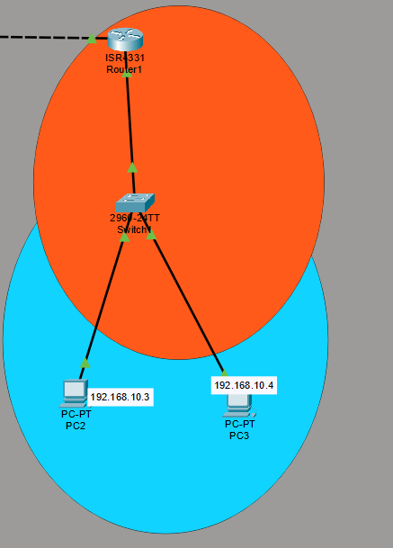

Lab – 5 Make local area network using switch

Goals & Competencies
By the end of this lab session, students should be able to:
- Define a Local Area Network (LAN).
- Build a LAN around a switch in Packet Tracer.
- Attach several computers to one switch.
- Give every device a proper IP address.
- Verify end-to-end communication capabilities across all devices connected to the LAN.

Practical Exercise

Background & Context
A Local Area Network represents a confined networking infrastructure spanning limited geographical areas such as laboratory environments, corporate offices, or educational classrooms. The central interconnecting device within such architectures is the network switch, which operates by receiving data frames and intelligently forwarding each unit exclusively to the port associated with the intended destination address. This targeted delivery mechanism significantly enhances network efficiency by eliminating unnecessary traffic propagation to unaffected segments.

Materials & Tools
- One 2960 switch
- Four PCs
- Copper Straight-Through cables
- Cisco Packet Tracer

Implementation Steps
Phase 1: Start Packet Tracer: Open the application.
Phase 2: Add the Devices: Add the switch (2960 model) and four PCs (PC-0, PC-1, PC-2, PC-3).
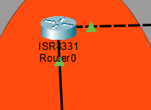
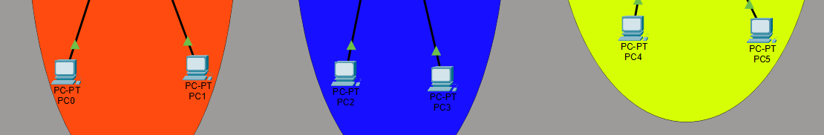
Phase 3: Cable the PCs to the Switch: Using Copper Straight-Through cable, attach every PC to a FastEthernet port of the switch.
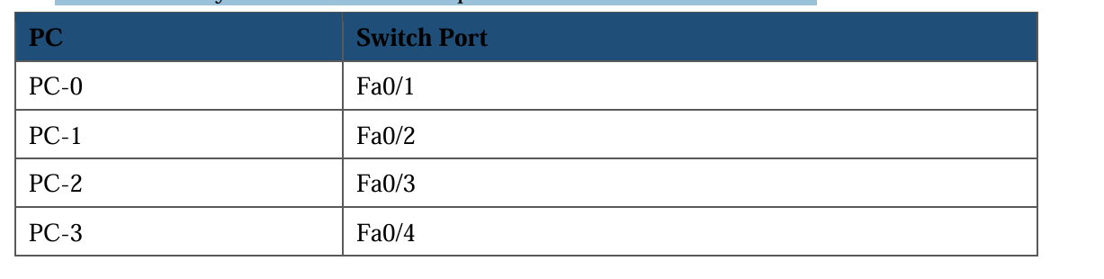
Phase 4: Assign IP Addresses: Configure each computer (subnet mask 255.255.255.0). Click each PC → Desktop → IP Configuration.
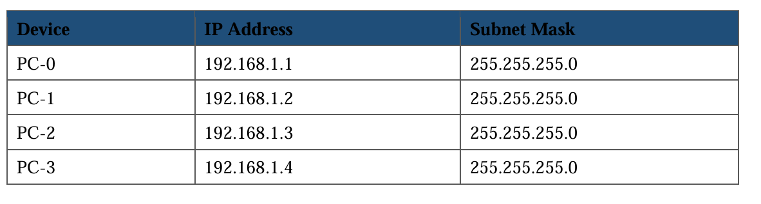
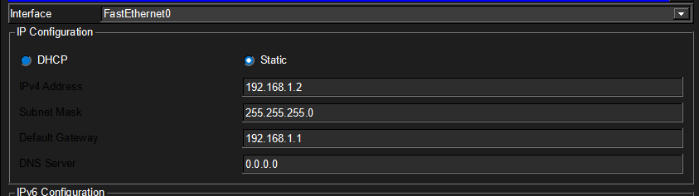
Phase 5: Test Connectivity:
- Click PC-0.
- Open Desktop → Command Prompt.
- Enter: ping 192.168.1.2
The successful echo replies demonstrate that the networked machines can establish communication pathways. Systematically repeat this verification process for each remaining workstation to ensure comprehensive connectivity.
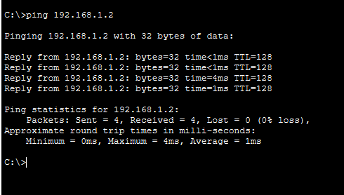
Phase 6: Simulation Mode:
- Switch to Simulation Mode.
- Use the Add Simple PDU tool.
- Send packets between different pairs of PCs.
- Observe the frames passing through the switch.
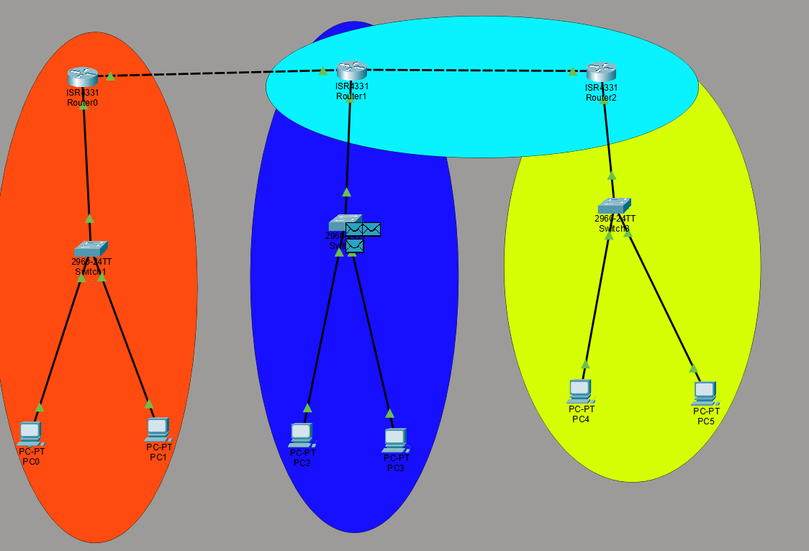
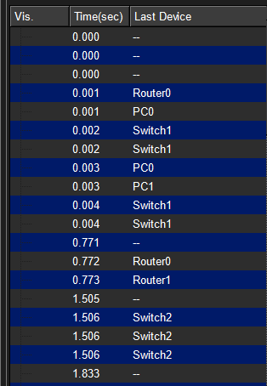

Lab – 6 Repeaters & Routers with Switches & Hubs

Goals & Competencies
By the end of this lab session, students should be able to:
- Describe the operational mechanisms of repeaters, hubs, switches, and routers within network architectures.
- Analyze and contrast the functional characteristics that distinguish each networking device category.
- Establish interconnections between these devices using Packet Tracer's cabling tools.
- Design and implement a functional network topology integrating routers, switches, and hubs.
- Validate seamless communication pathways throughout the entire network infrastructure.

Practical Exercise

Background & Context
Modern computer networking employs diverse hardware components, each fulfilling specialized functions within the communication hierarchy. Signal regenerators (repeaters) restore attenuated electrical signals to their original strength, hubs operate as broadcast devices distributing incoming data to all connected ports indiscriminately, switches utilize MAC address intelligence to route frames precisely to their intended destinations, and routers facilitate inter-network communication by evaluating IP addresses and determining optimal transmission paths.

Device Profile: Repeater
A repeater functions as a Layer 1 device that detects weakened or corrupted electrical signals and regenerates them to their original transmission strength, thereby enabling data to traverse extended physical distances. Its principal responsibilities include signal amplification, network segment extension beyond standard distance limitations, and mitigation of signal degradation effects inherent to copper-based media.
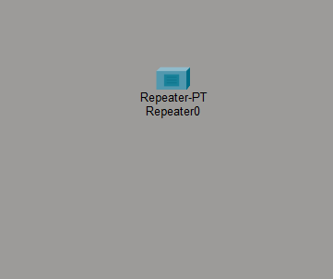

2. Hub
A hub represents the most fundamental interconnecting device within network topologies. Operating exclusively at the Physical Layer (Layer 1) of the OSI model, it indiscriminately replicates all incoming data received on any single port across every other connected port. This broadcast behavior creates substantial network overhead, introduces significant security vulnerabilities due to unrestricted traffic visibility, and yields inferior performance compared to intelligent switching devices.


Device Profile: Switch
A switch constitutes an intelligent Layer 2 device that dynamically constructs and maintains a MAC address table through observation of source addresses in passing frames. Leveraging this learned information, the switch makes precise forwarding decisions, delivering each data frame exclusively to the physical port where the destination device resides. This targeted approach dramatically reduces unnecessary network traffic and significantly enhances overall communication efficiency.
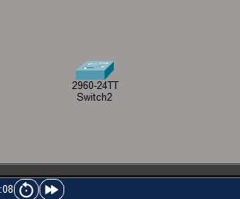

Device Profile: Router
A router operates as a Layer 3 device that interconnects distinct network segments and facilitates packet exchange between them through logical IP address evaluation. Its core responsibilities encompass unifying multiple network subnets, managing complex IP addressing schemes, and dynamically determining optimal routing paths using sophisticated algorithms and routing table analysis.
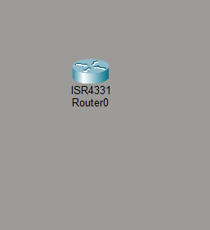
Required Components
- One router
- One switch
- One hub
- Four PCs (PC-0 to PC-3)
- Copper Straight-Through cables
- Cisco Packet Tracer

Implementation Steps
Phase 1: Start Packet Tracer: Open the application.
Phase 2: Place the Devices: Add one router, one switch, one hub, and four PCs.
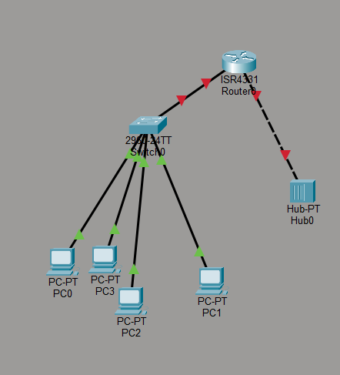
Phase 3: Make the Connections:
PCs to the switch:
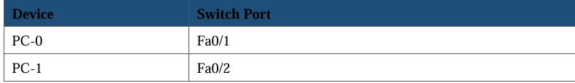
PCs to the hub:
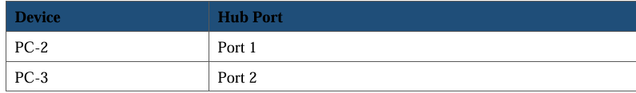
Switch and hub to the router:
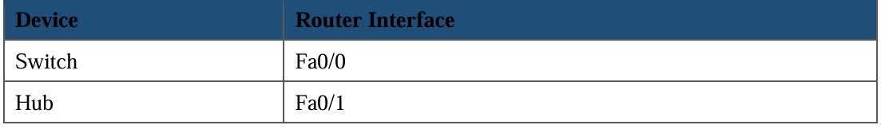

Phase 4: Assign IP Addresses: Configure Network 1 (switch side) with gateway 192.168.1.1.
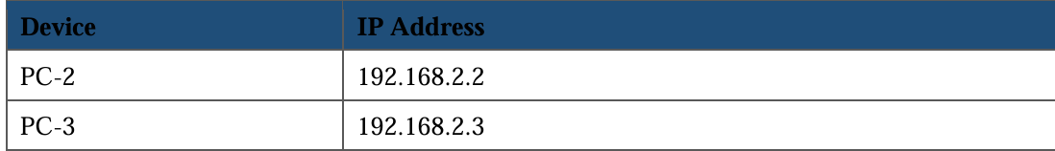
Phase 5: Configure the Router: Open the router CLI tab and enter configuration commands.
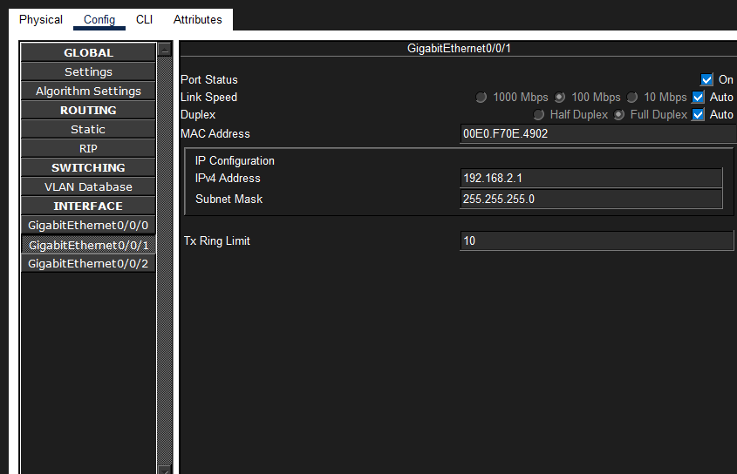
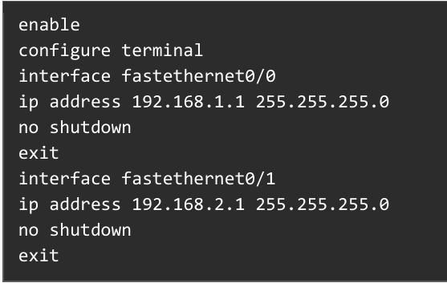

Lab – 7 Router Configuration

Goals & Competencies
By the end of this lab session, students should be able to:
- Articulate the fundamental functions performed by routers in interconnected network environments.
- Configure router interfaces using Command Line Interface operations within Packet Tracer.
- Establish direct physical connections between workstations and router ports.
- Implement IP addressing schemes on both end devices and router interfaces.
- Confirm successful data transmission across router-connected network segments.

Practical Exercise

Background & Context
The router serves as the cornerstone device for internetwork communication, responsible for interconnecting autonomous network segments and directing packet flows based on logical IP address destination information. These critical devices have become ubiquitous in modern connectivity infrastructures, deployed ubiquitously across residential broadband gateways, corporate branch offices, and enterprise data centers wherever inter-network traffic exchange becomes necessary.

Materials & Tools
- One router (1841 or 2911)
- Two PCs
- Copper Straight-Through cables
- Cisco Packet Tracer

System Architecture
In this topology configuration, PC-0 connects to the router's FastEthernet0/0 interface while PC-1 attaches to the FastEthernet0/1 interface. This arrangement places each workstation on a separate logical network subnet, necessitating Layer 3 routing functionality for inter-host communication.
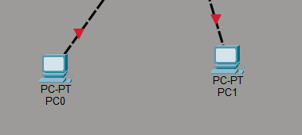
Procedure
Phase 1: Start Packet Tracer: Open the application.
Phase 2: Add the Devices:
- From the Routers category, choose the router model and place it in the workspace.
- From End Devices, place PC-0 and PC-1 on either side of the router.
Phase 3: Cable the Devices:
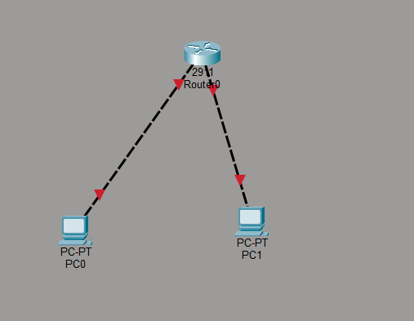
Phase 4: Configure the PCs:
PC-0 settings:
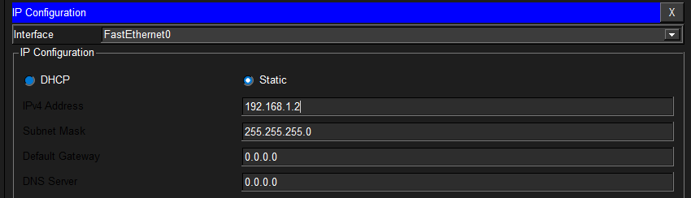
PC-1 settings:
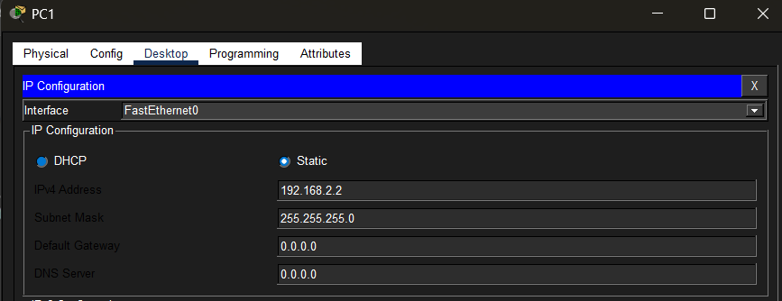
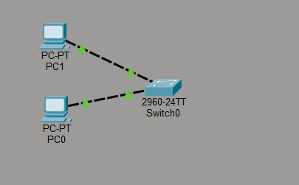
Phase 5: Configure the Router: Open the CLI tab and enter interface configuration commands for FastEthernet0/0 and FastEthernet0/1.
Phase 6: Verify Connectivity: Use the ping command from PC-0 to confirm communication with PC-1 through the router.

Lab – 8 Routers with Switches, PCs & Laptop / Bridges with 2 Switches, PCs & Laptop

Goals & Competencies
By the end of this lab session, students should be able to:
- Describe the function and significance of network bridges in LAN segmentation.
- Interconnect two switching devices using a bridge to create unified network segments.
- Construct a functional network topology incorporating desktop computers and portable computing devices.
- Implement appropriate IP addressing parameters on all terminal network devices.
- Validate comprehensive bidirectional communication capability among all networked devices.

Practical Exercise

Background & Context
A network bridge functions as a Layer 2 interconnection device that merges two distinct Local Area Network segments into a single unified logical network. Operating at the Data Link Layer of the OSI reference model, the bridge examines the Media Access Control addresses embedded within each frame and selectively permits cross-segment transmission only when the destination device resides on the opposing segment. This intelligent filtering mechanism effectively eliminates superfluous inter-segment traffic and substantially enhances aggregate network throughput. In this laboratory exercise, the bridge occupies a central position between two switches, with workstations and a laptop connected to the downstream switch ports.

Materials & Tools
- One bridge
- Two switches
- Two PCs
- One laptop
- Copper Straight-Through cables
- Cisco Packet Tracer

System Architecture
- Switch-0 carries PC-0.
- Switch-1 provides connectivity for PC-1 and Laptop-0 through its access ports.
- The bridge establishes the interconnection pathway between the two switching devices.
Procedure
Phase 1: Start Packet Tracer — Open the application.
Phase 2: Place the Devices: Add the bridge, two switches, two PCs, and the laptop.
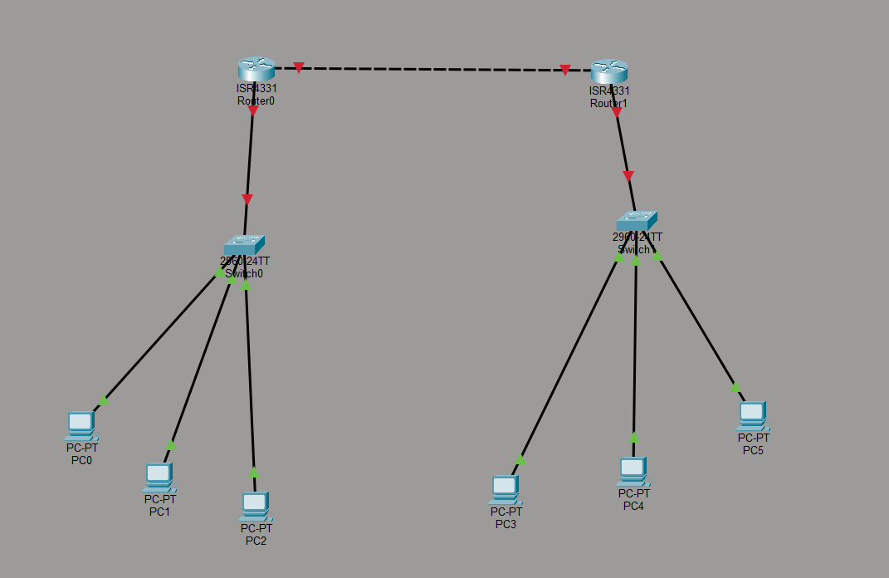
Phase 3: Make the Connections: All links use Copper Straight-Through cable; green lights confirm each connection.
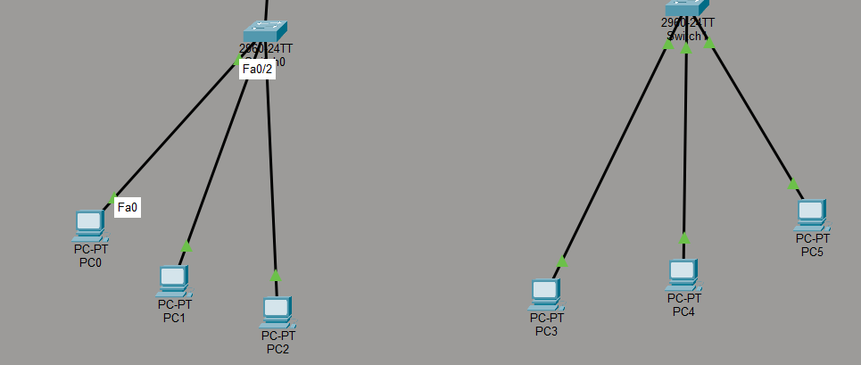
Phase 4: Assign IP Addresses:
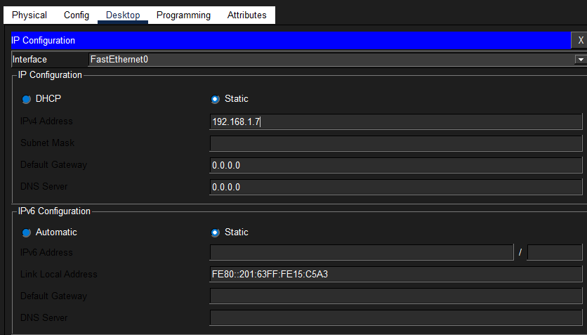
Phase 5: Test Connectivity:
From PC-0, open the command prompt and run:
ping 192.168.1.3
ping 192.168.1.4
Successful response messages received from both PC-1 and the laptop confirm that the bridge is correctly forwarding traffic between the two LAN segments.
Phase 6: Simulation Mode:
- Switch to Simulation Mode.
- Use the Add Simple PDU tool.
- Send packets between devices on opposite switches.
- Watch the frames travel through the bridge.
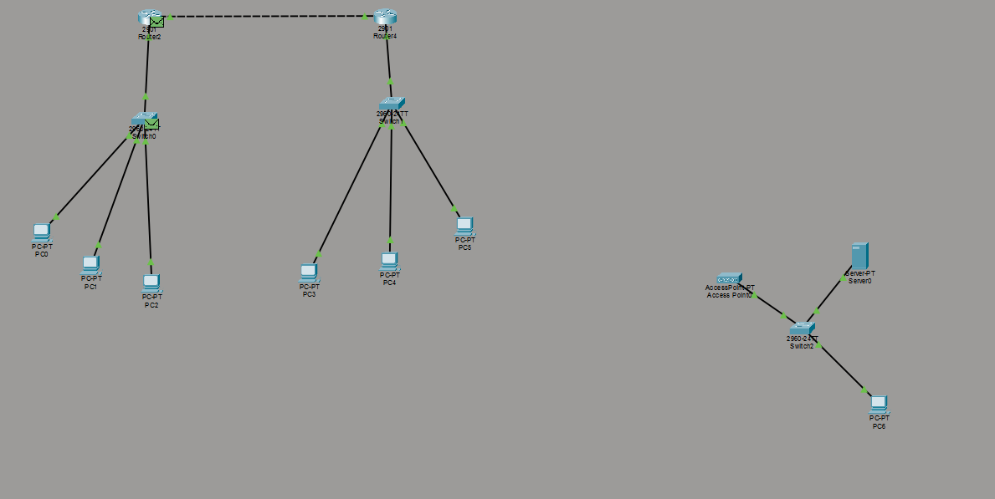

Lab – 9 Network Devices

Goals & Competencies
By the end of this lab session, students should be able to:
- Identify and enumerate the principal hardware components employed in contemporary network infrastructures.
- Elaborate on the specific operational responsibilities and functions of each networking device.
- Conduct comparative analysis highlighting functional similarities and distinctions between device types.
- Associate each hardware component with its corresponding position and contribution within the data communication process.
- Access, deploy, and configure these devices within the Cisco Packet Tracer simulation environment.

Practical Exercise

Background & Context
Network devices constitute the essential physical infrastructure components that interconnect computing systems and sustain continuous data flow across communication pathways. Each hardware category addresses specific functional requirements within the network ecosystem: switching devices direct traffic efficiently, signal conditioning equipment extends transmission distances, wireless access infrastructure provides untethered connectivity, and security appliances safeguard against unauthorized intrusions.

Device Profile: Router
The router establishes connectivity between autonomous networks and facilitates packet exchange across network boundaries through IP address evaluation. Core capabilities include: unifying multiple network subnets, determining optimal transmission paths using routing algorithms, maintaining dynamic routing information tables, and processing data at the Network Layer (Layer 3) of the OSI model.

Device Profile: Switch
The switch interconnects numerous devices within a unified Local Area Network. Primary functions include: precisely delivering data frames to intended destinations through MAC address lookup, minimizing unnecessary traffic propagation to reduce network congestion, and accelerating overall communication efficiency through intelligent forwarding decisions.

Device Profile: Hub
The hub provides fundamental connectivity for multiple computing devices. Operational characteristics include: broadcasting incoming data to all attached ports simultaneously, functioning exclusively at the Physical Layer (Layer 1), offering straightforward deployment with minimal configuration, and presenting inherent security limitations due to unrestricted traffic visibility.

Device Profile: Bridge
The bridge interconnects two Local Area Network segments while performing intelligent frame filtering based on MAC address analysis. Key benefits include: eliminating superfluous cross-segment transmissions, selectively permitting only necessary inter-segment traffic, and substantially enhancing aggregate network performance through reduced collision domains.
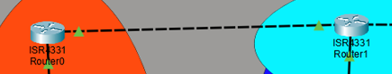

Device Profile: Repeater
The repeater regenerates deteriorating electrical signals to enable extended transmission distances. Principal functions include: overcoming copper cable distance limitations, restoring signal amplitude and clarity to original specifications, and mitigating attenuation-induced data corruption.

Device Profile: Modem
The modem performs modulation and demodulation operations, converting digital data signals to analog waveforms and vice versa. Essential capabilities include: enabling Internet Service Provider connectivity, transforming signal formats for appropriate transmission media compatibility, and serving as the boundary device between the service provider network and the local area infrastructure.

Device Profile: Access Point (AP)
The access point provides wireless-capable devices with network connectivity. Primary functions include: establishing wireless local area network coverage using IEEE 802.11 standards, authenticating and associating wireless client devices, and expanding the physical reach of network accessibility without wired constraints.

Device Profile: Firewall
The firewall operates as a dedicated network security appliance that protects infrastructure from unauthorized intrusion attempts. Core security functions include: bidirectional traffic inspection against established policy rules, blocking connections that violate security policies, and maintaining comprehensive network perimeter protection.
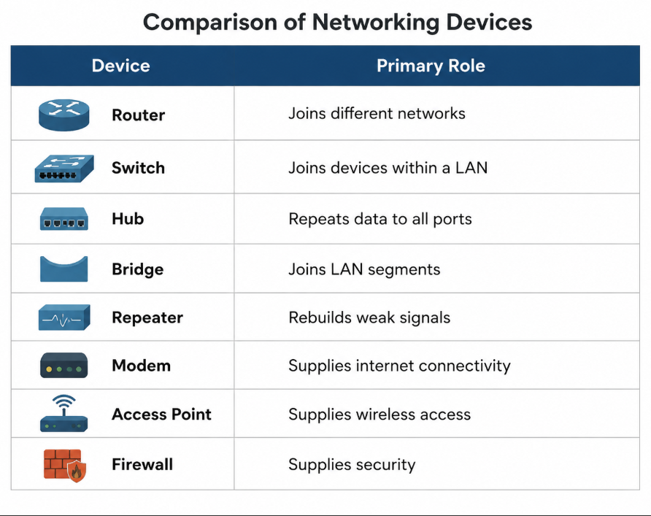

Lab – 10 Static Routing

Goals & Competencies
By the end of this lab session, students should be able to:
- Define static routing and articulate its operational principles.
- Manually configure static route entries on router devices within Packet Tracer.
- Establish internetwork connectivity by deploying multiple router devices.
- Implement interface configurations and host addressing parameters on routing equipment.
- Validate complete end-to-end data transmission capabilities across interconnected network segments.

Practical Exercise

Background & Context
Routing fundamentally refers to the process of directing data packets from their source network toward their intended destination network across interconnected pathways. In static routing implementations, the network administrator manually enters each routing entry into the router's configuration, and these routes remain fixed unless explicitly modified by administrative intervention. This manual approach offers several compelling advantages: configuration simplicity, predictable traffic behavior, and enhanced security due to the absence of dynamic route advertisements. Static routing proves particularly well-suited for small-scale network deployments where routing infrastructure changes infrequently.
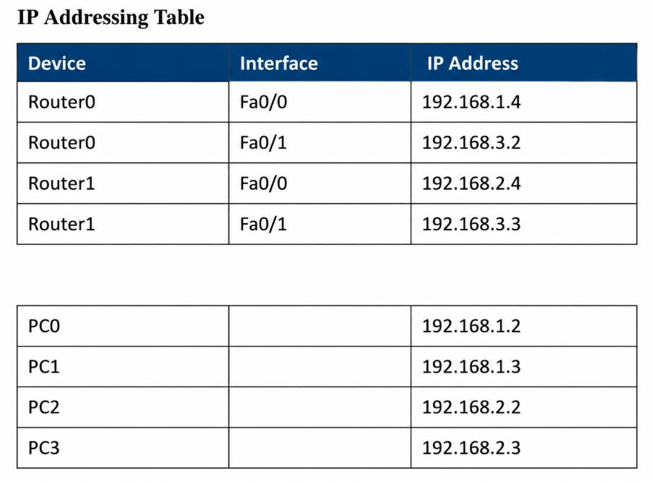
Required Components
- Two routers
- Two switches
- Four PCs
- Copper Straight-Through cables
- Serial DCE cable
- Cisco Packet Tracer

System Architecture
- The two routers establish their internetwork link through a dedicated serial interface connection.
- Each router provides Layer 3 gateway services to a directly attached switch.
- Each switch furnishes connectivity for two connected workstations.

Implementation Steps
Phase 1: Start Packet Tracer: Open the application.
Phase 2: Place the Devices: Add Router0, Router1, Switch0, Switch1, and four PCs.
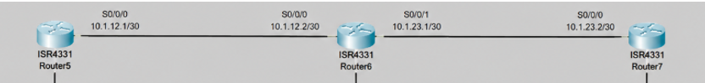
Phase 3: Make the Connections:
- Workstations connect to switch ports using Copper Straight-Through cabling.
- Switch-to-router connections utilize the FastEthernet0/0 interface on each routing device.
- The inter-router connection employs a Serial DCE cable linking the Serial0/0/0 interfaces.
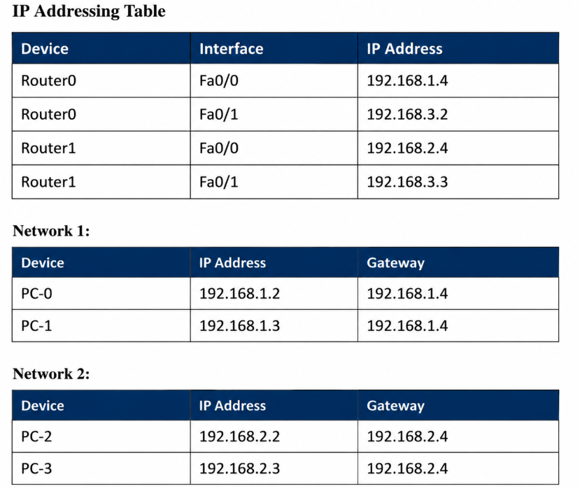
Phase 4: Configure the PCs: Assign IP addresses and default gateways according to the addressing table.
Phase 5: Configure Router0:
Open Router0 → CLI and enter:
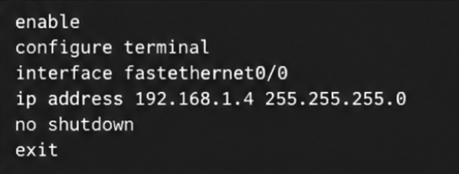
Serial interface:
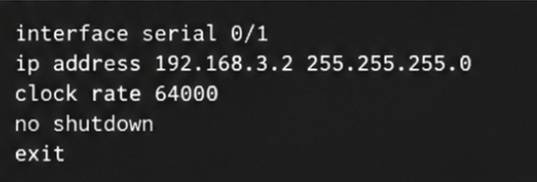

Phase 6: Configure Router1:
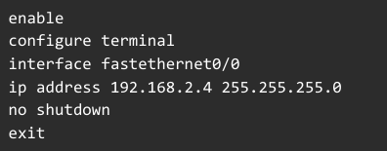
Serial interface:
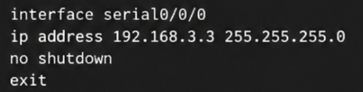
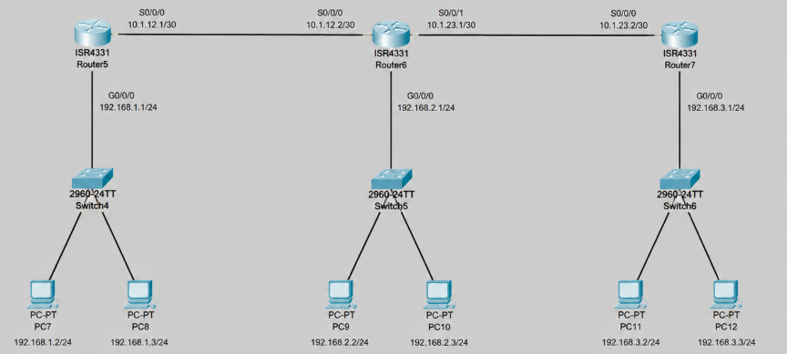

Lab – 11 RIP(Routing Information Protocol)

Goals & Competencies
By the end of this lab session, students should be able to:
- Describe the fundamental operational principles of the Routing Information Protocol.
- Activate and configure the RIP routing process on router devices within Packet Tracer.
- Establish connectivity between distinct network segments using dual router deployment.
- Enable automatic routing table synchronization between interconnected routers.
- Confirm successful inter-network data transmission and connectivity.

Practical Exercise

Background & Context
The Routing Information Protocol (RIP) represents a distance-vector dynamic routing protocol that automates the route distribution process. Rather than requiring manual administrative configuration of each route, participating routers actively broadcast their known network destinations to adjacent neighbors, enabling continuous routing table convergence. RIP exclusively employs hop count as its path metric, supporting a maximum of 15 hops between source and destination. Any network path exceeding this threshold (16 hops) is considered administratively unreachable, establishing a finite boundary for the protocol's operational scope.

Materials & Tools
- Two routers
- Two switches
- Four PCs
- Copper Straight-Through cables
- Serial DCE cable
- Cisco Packet Tracer

System Architecture
- Two routing devices establish interconnection through a serial communication link.
- Each router supports a downstream switch providing access-layer connectivity.
- Each switch interconnects two workstations within its broadcast domain.

Address Allocation Matrix
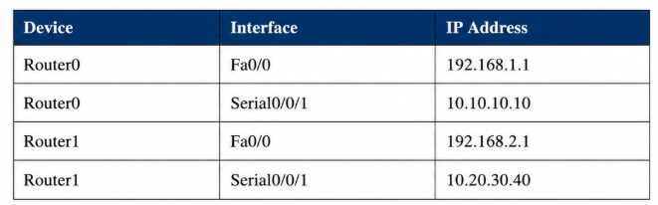
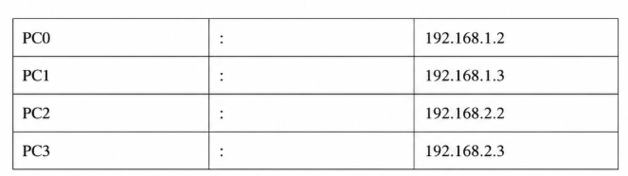
Default gateway configuration: endpoints on network 192.168.1.0/24 utilize 192.168.1.1 as their Layer 3 exit point; devices on subnet 192.168.2.0/24 direct outbound traffic through 192.168.2.1.

Implementation Steps
Phase 1: Start Packet Tracer: Open the application.
Phase 2: Place the Devices: Add Router0, Router1, Switch0, Switch1, and PC0 through PC3.
Phase 3: Make the Connections:
- PCs to switches with Copper Straight-Through cable.
- Each switch to Fa0/0 of its router.
- Router0 Serial0/0/0 to Router1 Serial0/0/0 with the Serial DCE cable.
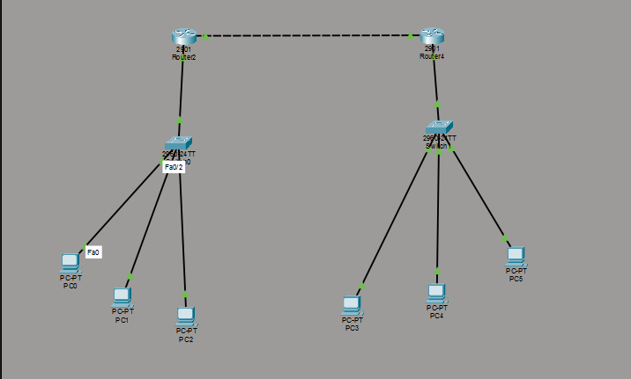
Phase 4: Configure the PCs: Give each PC its IP address and default gateway according to the addressing table.
Phase 5: Configure Router0 — Open Router0 → CLI and enter::
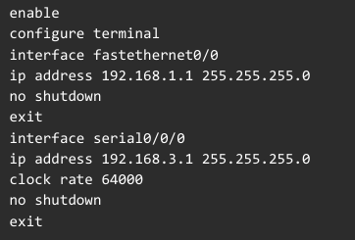
Enable RIP on Router0:
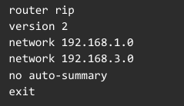
Phase 6: Configure Router1:
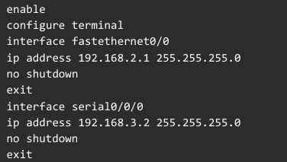
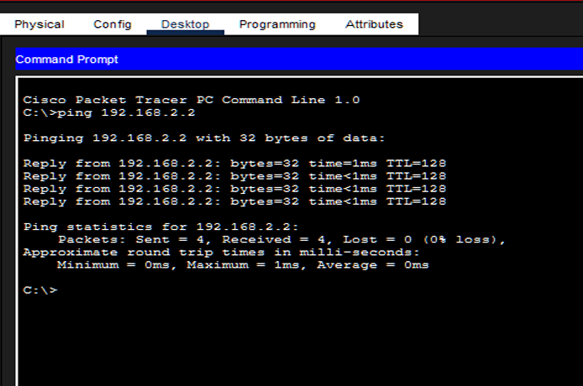

Lab – 12 Introduction to Subnetting

Goals & Competencies
By the end of this lab session, students should be able to:
- Define network subnetting and describe its architectural rationale.
- Partition a monolithic network address space into discrete smaller subnetworks.
- Compute appropriate subnet masks and determine precise subnet boundary addresses.
- Correctly identify subnet identifiers, valid host address ranges, and directed broadcast addresses.
- Implement a functional subnetted network topology within Cisco Packet Tracer.

Practical Exercise

Background & Context
Subnetting constitutes the process of dividing a large network address block into smaller, more manageable subdivisions known as subnets. This architectural approach yields numerous operational benefits including:
- Localizing broadcast traffic within individual subnet boundaries
- Enhancing overall network responsiveness and throughput efficiency
- Strengthening security posture through network segmentation and access control
- Maximizing utilization efficiency of available IPv4 address allocations
Every defined subnet encompasses three essential addressing parameters:
- Network Identifier – the initial address designating the subnet itself
- Valid Host Range – the consecutive addresses available for device assignment
- Broadcast Address – the last address in the subnet

Fundamental Principles
- IP Address: A logical address assigned to a device, e.g., 192.168.1.10
- Subnet Mask: Divides an IP address into network and host portions, e.g., 255.255.255.0
- Network Address: The subnet identifier, computed via bitwise AND of IP and mask
- Broadcast Address: The final subnet address for simultaneous delivery to all hosts

Illustrative Case Study
Consider the Class C network 192.168.1.0 with a default /24 prefix length and partition it into 4 equal subnets.
- To generate four distinct subnets, reallocate 2 bits from the host identifier field to the network portion of the address.
- The resulting subnet mask becomes 255.255.255.192, represented in CIDR notation as /26.
Subnet Breakdown:
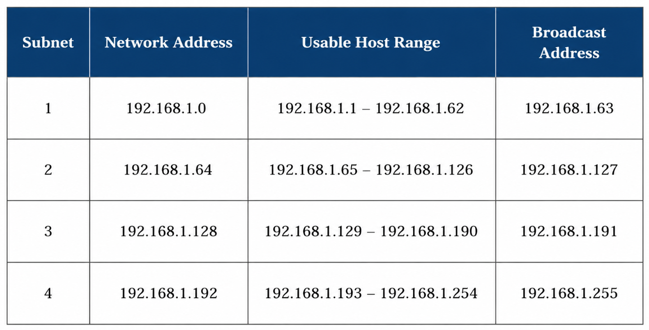

Materials & Tools
- One router
- Two switches
- Four PCs
- Copper Straight-Through cables
- Cisco Packet Tracer

Implementation Steps
Phase 1: Start Packet Tracer: Open the Cisco Packet Tracer application.
Phase 2: Place the Devices: Add the router, Switch0, Switch1, and PC0 through PC3.
Phase 3: Make the Connections:
- Connect each PC to its respective switch using copper straight-through cables.
- Connect each switch to a router interface.
Phase 4: Configure the Subnetted Addresses:
Subnet 1 (mask 255.255.255.192 /26):
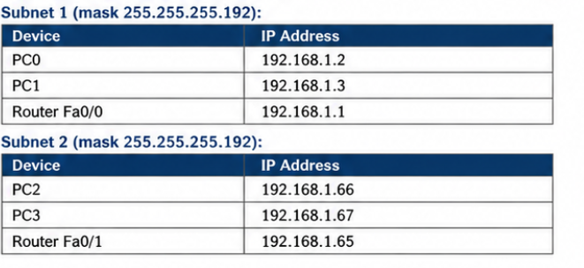
Subnet 2 (mask 255.255.255.192):
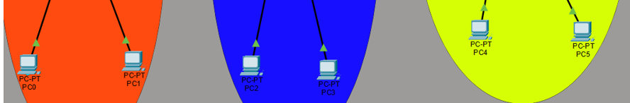
Phase 5: Configure the Router:
Interface Fa0/0:
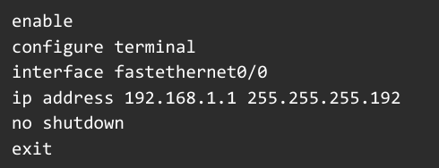
Interface Fa0/1:
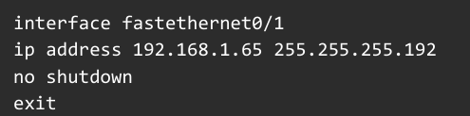

Lab – 13 IoT Simulation

Goals & Competencies
By the end of this lab session, students should be able to:
- Define the Internet of Things paradigm and describe its transformative impact.
- Deploy and configure intelligent device simulations within Cisco Packet Tracer.
- Integrate Internet of Things endpoints with wireless network infrastructures.
- Implement residential gateway parameters and wireless security configurations.
- Establish remote management and monitoring capabilities for smart devices using mobile applications.

Practical Exercise

Background & Context
The Internet of Things represents a revolutionary paradigm in which ordinary physical objects gain network connectivity and autonomous data exchange capabilities. These intelligent devices range from domestic appliances such as intelligent lighting systems, automated climate control units, electronic door locks, surveillance cameras, to environmental monitoring sensors. Cisco Packet Tracer incorporates a comprehensive library of IoT-enabled device models, providing learners with a robust platform for designing, implementing, and managing sophisticated smart-home and building automation networks within a controlled simulation environment.

Materials & Tools
- Home Gateway
- Smartphone
- Smart Fan
- Smart Light
- Laptop or PC
- Cisco Packet Tracer

Implementation Steps
Phase 1: Start Packet Tracer: Open the application.
Phase 2: Add the IoT Devices:
- From End Devices, place a Smartphone and a Laptop in the workspace.
- From Home Devices, add a Smart Fan and a Smart Light.
- From Network Devices → Wireless Devices, place a Home Gateway.
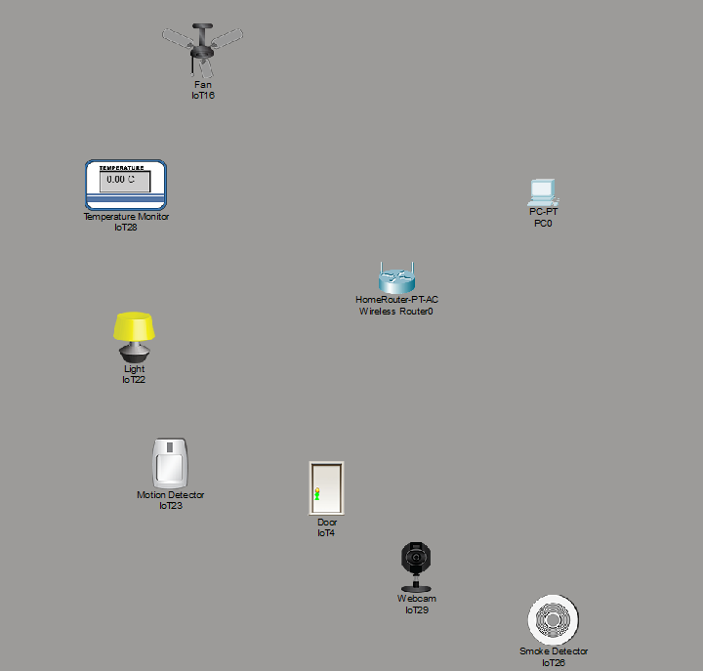
Phase 3: Connect the Devices: The smart devices attach to the Home Gateway wirelessly. Make sure every device is switched on.
Phase 4: Configure the Home Gateway:
- Click the Home Gateway.
- Open the Config tab.
- Apply the wireless settings below.
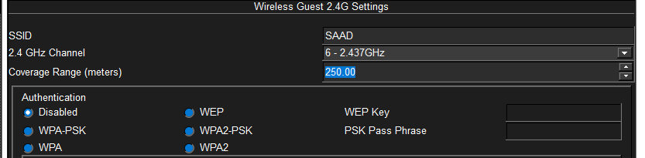
Phase 5: Join the Smartphone to the Gateway:
- Click the Smartphone.
- Open Config → Wireless0.
- Set the SSID to HomeNetwork.
- Enter the password 12345678.
Phase 6: Register the Smart Devices:
- Click the Smart Light → Open Config → Wireless → Join it to the Home Gateway network.
- Repeat the same procedure for the Smart Fan.
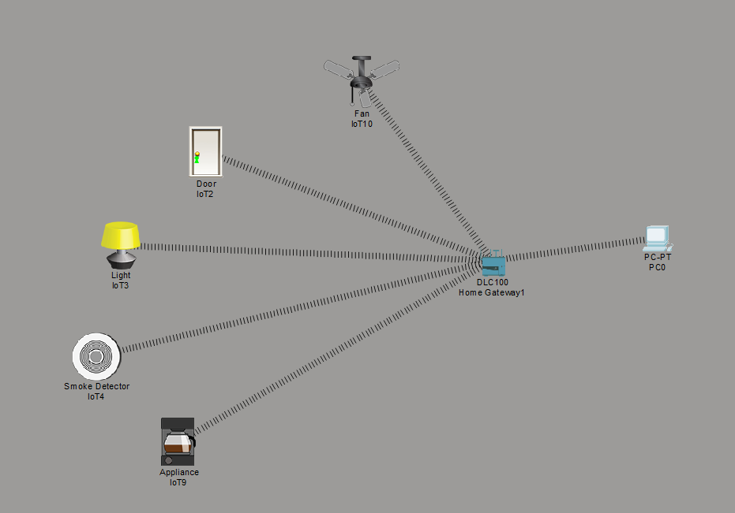

Lab – 14 Configuring VoIP phones using Cisco packet tracer (IP Telephony)

Goals & Competencies
By the end of this lab session, students should be able to:
- Describe the principles and mechanisms underlying Voice over Internet Protocol technology.
- Deploy and register IP telephone devices within the Cisco Packet Tracer simulation.
- Establish physical connectivity between VoIP endpoints and switching/routing infrastructure.
- Implement DHCP address allocation and telephony service parameters on the routing device.
- Demonstrate successful voice communication between two IP phone endpoints.

Practical Exercise

Background & Context
Voice over Internet Protocol technology enables the transmission of voice communications and multimedia sessions across packet-switched IP network infrastructures, including Local Area Networks and the global Internet, eliminating dependence on traditional circuit-switched telephone infrastructure. Through IP telephony, conventional networking equipment assumes the role previously fulfilled by dedicated Private Branch Exchange systems. Cisco Packet Tracer provides comprehensive IP phone models, empowering learners to construct and validate fully functional telephony systems within a virtualized laboratory setting.

Materials & Tools
- One router (e.g. 2811)
- One switch
- Two IP phones (7960)
- Two PCs
- Copper Straight-Through cables
- Cisco Packet Tracer

System Architecture
- The router establishes connectivity with the switch through an Ethernet trunk link.
- Each IP telephone registers with the switch via dedicated access ports.
- Workstations connect through the integrated PC pass-through port on each IP telephone unit.

Implementation Steps
Phase 1: Start Packet Tracer: Open the application.
Phase 2: Place the Devices: Add the router, switch, IP Phone0, IP Phone1, PC0, and PC1.
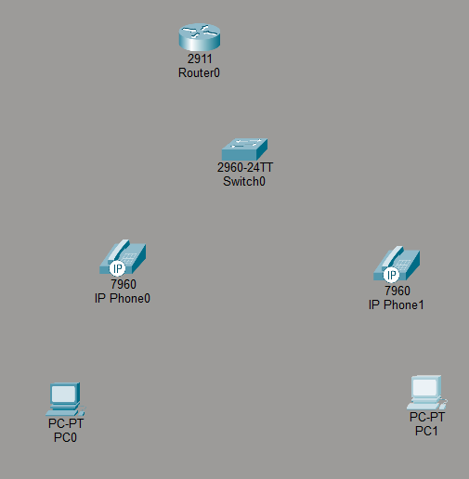

Phase 3: Make the Connections:
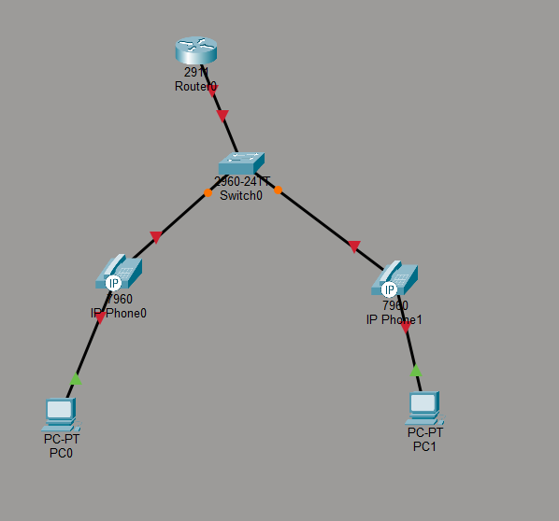
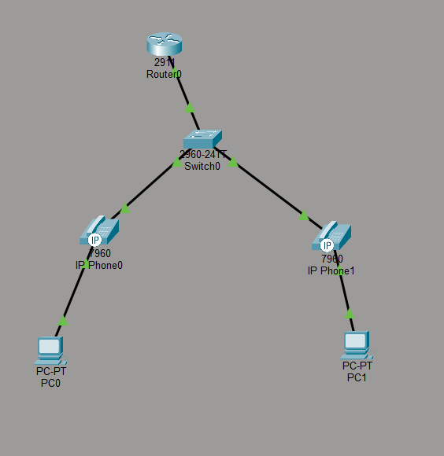

Phase 4: Configure the Router:
Fast Ethernet interface:
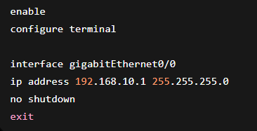
DHCP pool for the phones:
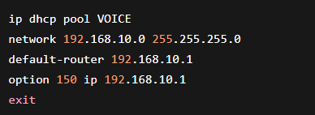
Telephony service:
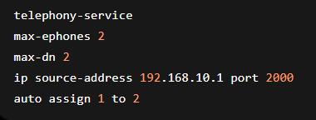
Phone extensions:
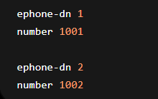
Phase 5: Wait for the Phones to Register: After a short delay, each phone automatically receives an IP address over DHCP and an extension number appears on its display.
Phase 6: Place a Call:
- Click IP Phone0.
- Dial 1002.
- Press the Dial button — IP Phone1 starts ringing.

Lab – 15 ACL configuration in cisco packet tracer

Goals & Competencies
By the end of this lab session, students should be able to:
- Articulate the security purpose and operational role of Access Control Lists in network protection.
- Construct and implement Access Control List rule sets on router platforms within Packet Tracer.
- Define traffic filtering policies that explicitly allow or deny specified network flows.
- Enforce access restrictions controlling communication between individual hosts or entire network segments.
- Validate Access Control List effectiveness through ICMP-based connectivity testing.

Practical Exercise

Background & Context
An Access Control List constitutes an ordered compilation of permit and deny statements deployed on network infrastructure devices to govern packet flow based on predefined matching criteria. These filtering rules evaluate packet header attributes including source IP addresses, destination IP addresses, transport layer protocols, and port numbers to determine whether to forward or discard the traffic. As a foundational mechanism of network security policy enforcement, ACLs serve as critical perimeter defense tools for protecting organizational network resources from unauthorized access and potential malicious activities.

ACL Classification
Standard ACL:
- Evaluates packets exclusively against the source IP address field for filtering decisions.
- Simple and widely used.
Extended ACL:
- Inspects source IP, destination IP, transport protocol, and port numbers for comprehensive filtering.
- Delivers significantly more granular traffic management capabilities.

Materials & Tools
- One router
- One switch
- Two PCs
- Copper Straight-Through cables
- Cisco Packet Tracer
Network Topology
- Both workstation endpoints (PC0 and PC1) establish connections to the switch ports.
- The switch maintains an uplink connection to the router interface.
- The Access Control List filtering policy is bound to the router's network interface.
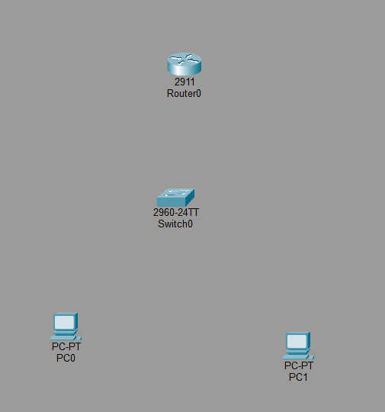

Address Allocation Matrix
All network devices utilize a /24 subnet mask (255.255.255.0) for address resolution.
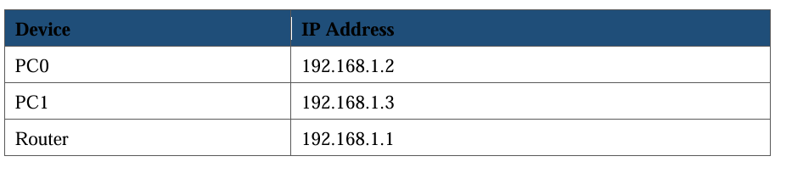

Implementation Steps
Phase 1: Start Packet Tracer: Open the application and create a new workspace.
Phase 2: Place the Devices: Add the router, the switch, PC0, and PC1.
Phase 3: Make the Connections: Using Copper Straight-Through cable, attach PC0 and PC1 to the switch, and the switch to the router.
Phase 4: Configure the PCs: Assign IP addresses and default gateways to PC0 and PC1.
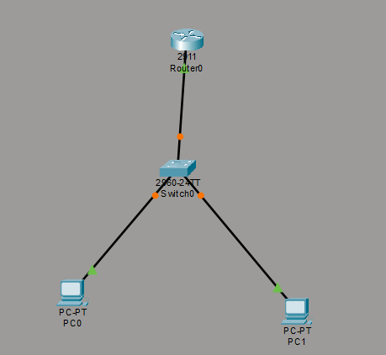

Phase 5: Configure the Router Interface:
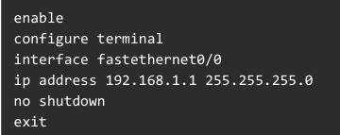
Phase 6: Create the Standard ACL:
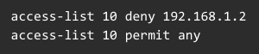
Bind the Access Control List to the appropriate router interface in the designated direction:
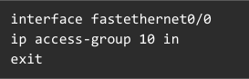
Phase 7: Test the ACL:
